**The social construction of algorithmic practice: taking an information distribution platform as an example**

Author: Zhao Lu

2022-08-02

<http://sociologyol.ruc.edu.cn/shxyj/fzshx/wlshx/82815388e724404aa327afb445f377df.htm>

**Abstract:** This paper takes an information distribution platform as a case study, regards the algorithm that affects the visual presentation of information in the AI ​​era as a practical logic, and attempts to analyze the social construction process of algorithmic practice by combining the institutional attributes of the organization with the subjective initiative of the actors. The study found that core social actors have differentiated game positions under the power-interest influence mechanism, and engage in complex strategic interactions and games around content (in)visibility. Based on the case analysis, this paper extracts two key influencing dimensions: the intensity of control and the relevance of interests, providing possible analytical ideas for the study of AI technology and social relations and algorithmic governance.

**Keywords:** algorithmic practice; information distribution platform; AI technology; social actors; visibility game

**About the author:** Zhao Lu (Assistant Researcher, Institute of Sociology, Beijing Academy of Social Sciences)

**1. Problem Statement**

From the perspective of the academic tradition of sociological research, since Merton established the "Science-Technology-Society" (STS) framework, the discussion on the relationship between technology and society has been caught up in multidisciplinary scrutiny and debate. Compared with the discussion of the philosophy of technology by natural dialectics, mainstream sociological research focuses more on issues related to social structure, social relations and social action (Qiu Zeqi, 2017; Xia Baohua, 2015; Li Sanhu, 2015). Looking back at the thought threads and theoretical traditions of classical sociological theorists, technology is more often regarded as a social component. For example, the Marxist research tradition will explore the role of technology in promoting industrial productivity and whether technology will aggravate social inequality after being infiltrated by politics (Marx, 1975); the Weberian tradition focuses more on the impact of technology on the degree of social rationalization (Weber, 2010); and Durkheim's theoretical thought tradition may focus more on the extent to which technology, as a social fact, affects social solidarity (Durkheim, 2000). Therefore, for a long time, technology has often become the "background" or limiting factor of major topics in empirical sociological research (such as social stratification and mobility, social relationship networks, labor-capital relations, etc.). Empirical researchers tend to pay more attention to the logic and new characteristics of technology and the important role they play in the transformation of social order and social relations, but their understanding and analysis of technology itself is very limited.

Existing sociological empirical research has made considerable efforts and attempts in the discussion of traditional production technology, information technology application and social change, gradually incorporating technology discussion from technology determinism into the social context of "application", observing the organizational structure changes in the process of technology introduction and application between organizations and departments (Zhang Yan, 2009), organizational culture changes (Ren Min, 2012), traditional technology coordination and integration (Zhang Maoyuan, 2007), the impact mechanism of technology application on rural industrialization and the reshaping of social order (Zhang Shuqin, 2018), etc. With the advent of the era of big data and artificial intelligence technology, sociology needs to re-explore technology issues in the digital age, especially the experience accumulation of expansive analysis of technology, because technical elements, technical processes, and the hierarchical structure of technology are all indispensable key analysis variables (Arthur, 2009). Therefore, this article hopes to cut into the core technology of digital society - algorithm (Qiu Zeqi, 2021) in the process of designing and applying artificial intelligence technology.

The algorithms of digital society are not only used as methods and steps for machine learning to solve problems in a technical sense (Kitchin, 2016) to regulate, produce and manage digital devices (Steiner, 2013), but also as a technical-social practice process, which requires artificial rules and strategies to design, define and evaluate, involving the social process of production, consumption and use (Willson, 2017). Therefore, algorithmic practice becomes the operating rules of the combination of people and code, and we cannot ignore the subjective initiative of humans in it. This article explores an empirical research path from a sociological perspective, and answers the following research questions through a case analysis of the algorithmic practice process of an information distribution platform (hereinafter referred to as K platform): How is algorithmic practice carried out? Which social actors will participate in the algorithmic practice and algorithmic construction process? What are the logic, strategy and influence mechanism of participating in algorithmic practice and algorithmic construction? What kind of information dissemination order is reorganized by the social construction process of algorithmic practice?

**2. Literature Review and Analytical Framework**

This article mainly follows the social constructionist paradigm in sociological research and analyzes the process and mechanism of algorithm practice of the large platform enterprise K platform. This section first sorts out the paths and shortcomings of algorithm research in the current social science field, and then proposes the analytical framework and content arrangement of this article based on the social constructionist paradigm of technology.

**1. Current paths and shortcomings of algorithm research in the field of social sciences**

Computer science research and industry pursue efficiency under the logic of technological rationality, taking algorithms as the center of technical systems, exploring how social environments are transformed into computable processes, and seeking effective, robust, relatively fair and responsible ways to improve organizational benefits and infer user behavior (Schmidt & Wiegand, 2017). Many disciplines in the humanities and social sciences usually incorporate algorithms into a broader social technology combination, and this research orientation has become a consensus in academia (Goffey, 2008; Bucher, 2012). Overall, there are two perspectives on algorithm research in the current social sciences.

**1. Technological Cybernetics**

This research path emphasizes that algorithms in the digital society have the ability to control and influence social reality (Lazer, 2015) and social order (Beer, 2017). Most researchers believe that algorithms, as technological social rules, automatically regulate social operations (Liang Yucheng and Zheng Guangjing, 2021). The highly adaptive characteristics of algorithms (autonomous learning and automated decision-making functions) can control data flow and human behavior, making social operations in a "black box" state (Pasquier, 2015), and comprehensively controlling human production and life. The algorithmic society is coming (Peng Lan, 2021), and humans will face a series of uncontrollable social risk consequences. For example, people's subjectivity is backfired by the technical rationality of intelligent algorithms, generating "algorithmic Leviathan" (Zhang Aijun, 2021; Fan Ruguo, 2021), social discrimination (Wang Huaijun and Ru Xuhua, 2020), imbalance between public and private power (Zhou Hui, 2019), labor process control and workers' resistance (Rosenblat, 2018; Sun Ping, 2019; Chen Long, 2020), and so on. In the research of this path, although no author claims that algorithms determine social structure or that algorithms change the way society interacts, they all implicitly emphasize the coercive nature of algorithms in controlling society. This often ignores the practical attributes of algorithms themselves in interacting with social actors, and does not analyze the complex interactive processes such as the structural conditions, practical scenarios, and artificial institutional arrangements under which algorithms exert their influence.

**2. Technology Tool Theory**

This path of research believes that algorithms are not autonomous, and that they are only efficiency tools, not self-decision-making systems (Qiu Zeqi, 2021). On the one hand, it emphasizes that algorithms can be applied to public services such as government decision-making, comprehensive monitoring, and security risk identification to improve governance efficiency (Levy et al., 2021; Chen Yunsong, 2021); on the other hand, it emphasizes the dominant role of strong economic interest groups in algorithm design. Most researchers believe that algorithm design and application are easily manipulated by business organizations and technical elites, and that algorithms are easily "empowered" by politics and business, becoming agents of power and bringing new social divisions and inequalities (Burrell & Fourcade, 2021) and the risk of power alienation (Zhang Linghan, 2021). As a result, algorithmic power has become a political issue that needs to be technically regulated by social intervention. Research on algorithmic supervision (Yeung, 2018) and algorithmic governance (Katzenbach & Ulbricht, 2019) focuses on institutional reconstruction, legal regulation (Ding Xiaodong, 2020), technical ethical responsibility (Cheng et al., 2021), public policy innovation (Jia Kai, 2019), corporate social responsibility governance (Yang Zhen, Chen Jin, 2021), and source participation of social sciences (Zhou Lujun, Lv Peng, 2022). This makes how to guide algorithms to be good, enhance their explainability, and regulate the behavior of responsible entities in algorithmic applications an action practice for policy issuance and industry discussion and practice. The research of this path does not separate algorithms from political, cultural, and social backgrounds (Jia Kai et al., 2021), but highlights the influence of institutional factors on algorithms, providing us with ideas for empirical research. But overall, this path does not pay enough attention to the subjective initiative of social actors, and ignores the interactive strategies and practical capabilities of social actors behind specific organizational structures and institutional arrangements.

Through a comprehensive review of the above research paths, we can gain the following insights. First, at the theoretical level, research tends to go to the extreme of "technological determinism", causing algorithm anxiety in public discourse. Existing literature focuses more on the opacity, difficulty of explanation, and adaptability of algorithms and the technical systems in which they are located. The implicit meaning is that once algorithms are put into practice, they will affect individual behavior, organizational methods, and social structures, and to a certain extent ignore the role of human subjective initiative in algorithm design and application. Secondly, from the perspective of empirical research paths, the psychological processes of individual or collective actors are basically not presented. Existing research often has more ought-to analysis and less is-to-be analysis, and lacks empirical empirical research cases. Thirdly, it is necessary to pay attention to the spatiotemporal continuity of algorithm practice. In the past, production technology and information technology had the characteristics of spatiotemporal discontinuity in the design and use process (for example, technology developers and users in different organizations have introduction/application trading behaviors, etc.), but algorithm practice is always connected with organizations (designers and managers) and users (data production and consumption) throughout the design, application, and iteration life cycle, and even changes accordingly with changes in the organizational institutional environment and user cognition and action characteristics. Therefore, algorithm research in the digital age cannot be limited to the linear impact relationship between algorithms and society, but should focus on the dynamic process analysis of the complex relationship between algorithms and society. We acknowledge that algorithms and the technical systems in which they are located play an important role in human society, but this does not mean that the configuration of technical systems is obscured by power control at the organizational level and technical operation details.

**2. Research path and analytical framework of this article**

Based on the existing research, this paper, relying on the social constructionist paradigm, attempts to incorporate algorithm research into the research framework of "technology-organization-individual" from the perspective of practical logic, and transforms from the simple causal analysis path of exploring algorithm-social relations to the social construction process-mechanism analysis path, thereby proposing an integrated analytical framework. It specifically includes three sets of concepts: organizational institutional attributes-individual active attributes, power-interest relationship mechanism and actor cognition, strategy, and visibility game. The three concepts present a progressive relationship in epistemological logic. Among them, the organizational institutional attributes-individual active attributes are intended to find the occurrence basis of the social construction of algorithm practice and answer which social core actors participate in the algorithm practice process; the concept of power-interest relationship mechanism and actor cognition and strategy attempts to explain the interactive process of core social actors participating in algorithm practice; and visibility game is used to analyze the interactive results of core actors participating in algorithm practice. This framework can specifically show the temporal and cyclical construction process of multiple social actors in algorithm design, decision-making, and application.

**1. Organizational system attributes - individual initiative attributes**

Technology can reflect both the institutional attributes and individual initiative attributes of an organization in its development and application. The organization's own structural form, organizational culture, business strategy, laws and regulations in the external environment pressure dimension, market competition, and the country's formal institutional arrangements, socio-economic conditions and other institutional factors can construct the technology system and give it meaning (Scott, 2011). The institutional attributes of the organization influence technology through technical interactions mediated by organizational managers and technology designers/developers (Orlikowski, 1992). At the same time, actors who have relatively little control over technology can still change the way technology is interpreted and operated, and even change the meaning of technology to the organization (Wynne, 1988).

This article regards the algorithmic practice process as a process of continuous interaction between the technical system and the social system. Human agency and the institutional attributes of the organization can coexist in algorithmic practice. Therefore, incorporating the agency characteristics of different actors in the algorithmic practice process (artificial rules, strategies, evaluations, intervention actions, etc.) and the institutional contextual characteristics acting on specific organizations inside and outside the algorithm into the entire life cycle of algorithm design, application, and iteration for research can help us better understand which actors participate in the social construction process of algorithmic practice and how they participate in the process of algorithmic practice.

**2. Power-interest relationship mechanism and actor cognition and strategy**

In the process of analyzing the organizational and institutional attributes and individual initiative of algorithmic practice, after incorporating the core actors involved in social construction, what is the mechanism that affects the participation of multiple actors in algorithmic practice? This article believes that it is necessary to start from the game status, algorithm cognition and action strategies of multiple actors in the process of algorithmic practice, and analyze the power-interest relationship mechanism hidden behind it, which is also the deep motivation that affects the results of algorithmic practice.

(1) Social actor’s game position. Sociological research on organizations often starts from power (Foucault, 1999). In social exchange relationships, the way power operates depends on the degree of equal exchange resources between the two parties, the degree of substitutability of the other party, the degree of force, and the ability to refuse exchange/services (Blau, 1988). The range of behavioral choices in these four aspects is manifested in the two actors in the interactive game, which directly affects their respective interactive game positions. If the organization itself, as a social actor, needs to continuously exchange with external resources, its game position is easily affected by the external control force that controls the resources it needs. Resource ownership, actual use rights, and the ability to formulate regulations or supervise resource ownership and use rights can all become sources of social control faced by the organization (Pfeffer and Salanjik, 2006). Then, from the perspective of the game position of social actors, examining technology (resources), the possession of technology and the use of technology (Wang Shuixiong, 2000) become two key dimensions of power games. It can be seen that the greater the amount of resources that can establish equal exchange, the more alternative services are available to the actors, the more powerful, the more stable the power, and the greater the amount of resources that can sustain survival, the higher the game position of the actor (of course, in interactive games, different actors will decide according to the actual game scenario and behavioral orientation). Under the organization-technology-individual framework, this is of great significance for better observing and analyzing the internal influence mechanism of different social actors in the process of participating in algorithmic practice, that is, the intensity of control of different social actors in the process of algorithmic practice directly affects the game position of participating in algorithmic practice.

The intensity of control rights specifically involves the degree of influence on the algorithm practice process, including the data actor's ability to control information exchange, the ability to manipulate algorithm design and application, and the ability to change and intervene in the results of algorithm practice. First, the algorithm cannot be separated from data practice (Balkin, 2017). The data actor has the right to self-determination of personal information and the ability to actively intervene in his or her own "digital personality" (Wang Zejian, 2008). He or she has autonomous control over how to use his or her own data to "connect" the platform for resource exchange and accept/reject services. For example, the user's own behavioral feedback can be self-controlled, and the scope and ranking of content visibility can be changed through active self-indexing and classification of others and content (Brubaker, 2020). Secondly, algorithm practice is a technical coding process. How to design, operate, and formulate strategies and rules exists within the organization. It is undeniable that the organizer has the actual power to control technology, but the dependence of any technical design process on the social environment and culture cannot be ignored (Feenberg, 1999). For example, the premise of algorithm practice is that it needs to serve specific business scenarios and product goals. There will also be differences in the algorithm practice characteristics of public power decision-making institutions and commercial companies (Ding Xiaodong, 2020). For the current large platform companies that have both quasi-public power attributes and commercial attributes (Liu Quan, 2020), algorithm practice will also take into account the nature of public decision-making power and corporate autonomous decision-making power. Therefore, the algorithm practice process provides the possibility for the power transmission of multiple social subjects. Finally, multiple social actors have the ability to manually intervene in the results of algorithm practice. From the perspective of the organization, managers and technical elites have the authority to manually intervene. From the perspective of the outside of the organization, any data behavior subject has the right to refuse/close algorithm automated decision-making. Article 22 of the EU's General Data Protection Regulation (GDPR) stipulates that "when algorithm automated decision-making has a legal or significant impact on the data subject, the data subject has the right not to be the subject of automated decision-making"; Article 17 of my country's "Internet Information Service Algorithm Recommendation Management Regulations" clearly states that "if the user chooses to close the algorithm recommendation service, the algorithm recommendation service provider shall immediately stop providing the relevant service." Moreover, corporate organizations themselves face constraints from external political coercion. For example, the intervention capacity of the state’s technological governance autonomy can override the autonomy of specific departments, groups, and classes (Castells & Cardoso, 2006) to regulate the negative consequences of algorithmic practices.

Interests are the inherent rational motivations for the behavior of actors. Actors within an organization will analyze their respective benefits under specific conditions based on their own goals, and then determine the corresponding action strategies and behaviors (Becker, 1976). Technology applications exist not only within organizations, but also in social interactions. Relevant interest groups not only have the ability to construct technology (Newman & Rosenberg, 1985), but can also exert their own influence on technology design by providing or controlling resources, so that technological activities are included in the technological order that suits their respective interests (Feinberg, 2005). Since the algorithm practice process affects the economic interests of the platform organizer as the algorithm designer and operator and the distribution of interests of relevant stakeholders, such as consumer experience, advertiser revenue, and worker profit (Cotter, 2019; Zhai Xiufeng, 2019), as well as the needs of social public interests such as government regulatory agencies, media, and public opinion supervision (Velkova & Kaun, 2021; Zhang Zhian and Zhou Jialin, 2019), what is hidden behind the algorithm practice process is the change and adjustment of the interest pattern of the behavioral subject. The degree of stakeholder involvement in the algorithmic practice process is a key variable that influences the strategic choices of actors.

This article combines the two dimensions of control intensity and degree of interest involvement mentioned above, and attempts to make a preliminary division of the bargaining positions of multiple social entities involved in the algorithm practice process (see Table 1 for details). The specific content and corresponding relationship of the four quadrants A, B, C, and D need to be verified by subsequent empirical analysis.

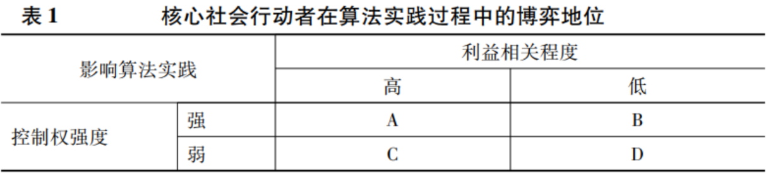

(2) Algorithmic cognition and action strategies. There is an ontological debate on the understanding of algorithms (Gillespie, 2016), and different actors within an organization often interpret them according to their own status and role in the organizational structure (Xu Di, 2019). Applicants outside the organization will equate algorithms with technical rules or systems (Seaver, 2017), and there will be differences in knowledge and blind spots in terms of manipulation when interacting with them (Cotter & Reisdorf, 2020). Therefore, different social actors will form different algorithmic cognitions based on their different knowledge reserves, skills, and roles in the algorithmic practice context, and give different meanings and expectations. Such cognition and expectations will greatly affect the interactive logic and action strategies of actors participating in algorithmic practice.

**3. Algorithm Practice Results - Visibility Game**

Any technology, from innovation to actual social, economic, and organizational effects, will go through many links such as design, decision-making, application, and feedback. Previous studies have placed the interaction between technology and related actors in the link of technology application (Qiu Zeqi, 2005), but unlike the exogenous customization of information technology, artificial intelligence technology is, to some extent, in a continuous cycle of design, decision-making, and application. In this cycle, technical logic, organizational logic, and user logic work together. That is, the result of algorithmic practice is a state of mutual influence in a specific time flow and context, rather than a static, fixed result. Therefore, the strategic interaction between actors in different practice contexts and the resulting state should be analyzed.

This article uses the "visibility" game as a concept to understand the results of algorithmic practice. By studying the process of different social actors participating in the construction of algorithmic practice, this article analyzes how algorithmic practice presents the game state of different social actors. Then, in the case study of this article, how content identification, review, distribution, and recommendation under algorithmic practice ultimately determine what content should be (in)visible, and who they are visible to, it presents the game state of multiple subjects on the visibility of content in the information flow.

**3. Algorithmic Practice: Balancing the Power and Interest Game of Different Social Forces**

This article uses the large platform enterprise K platform as a case study. The materials used come from the author's field survey of the platform company from September 2020 to June 2021, as well as questionnaires and interviews with external relevant organizations, groups and individuals. During the field research, the author collected materials including in-depth interviews with internal managers, content operators, and algorithm engineers, as well as minutes of meetings in which the author participated in the project, user questionnaire data, regulatory measures of government regulators, and media reports (anonymized in the article). After K platform was transformed into an intelligent information distribution platform with AI technology as its core in 2012, it quickly entered people's daily lives (with more than 300 million daily active users). This not only means that the accumulation of big data in the consumer field (to C end) is more complete and AI technology is more mature, but also that the algorithm practice of the information distribution platform involves different links of content distribution (assisted creation, review, distribution, personalized recommendation), so the scenarios of algorithm practice are more diverse and the fields of interaction with social actors are more complex. This provides a typical case for revealing the interweaving and integration of machine learning algorithm practice and platform organization in the digital era, presenting a complex, dynamic and co-evolutionary process. As the core node of information distribution and the infrastructure for the construction of technological culture (Gillespie, 2010), the platform connects different market players (ownership companies, advertisers, e-commerce, etc.) in the process of continuous algorithmic practice, and also incorporates workers, consumers, and government regulatory agencies into the interaction with the technological system, jointly participating in the construction of information order (as shown in Figure 1).

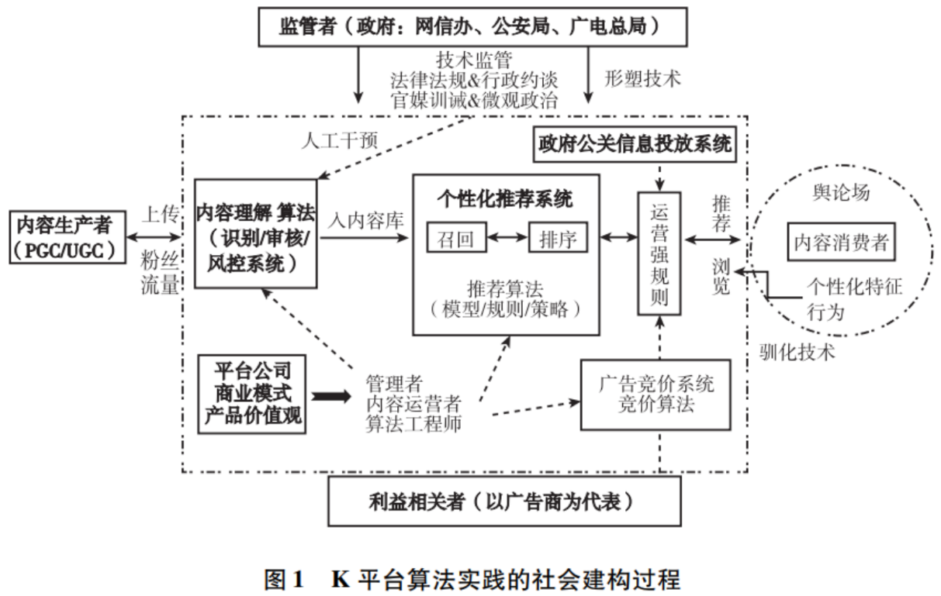

When the author interviewed the algorithm engineer of the K platform during the field work and asked him how he viewed the significance of the AI ​​algorithm (technical system), the engineer said, "The AI ​​technical system needs to meet the demands of different stakeholders. As the platform dynamically adjusts during its development stage, the role of the algorithm is to comprehensively maximize the interests of all parties and constantly achieve a balance" (Interview record of C2, algorithm engineer of recommendation system, 20210302).

It can be seen that algorithmic practice is undergoing continuous evolution and iteration, dynamically adjusting the direction of information flow to make it more in line with the demands of relevant stakeholders. So, why has algorithmic practice become a process of balancing the rights and interests of multiple social entities?

**1. The “inclusive” logic of algorithmic practice: the demand and balance between content production and consumption**

For platform companies, they have dual roles. As platform organizations in the social and cultural sense, they are technical intermediaries that coordinate multilateral rights holders. The logic of algorithm practice carried out by different platform companies is similar. They are all about matching people and information (people) efficiently. The difference lies in the trade-offs in the balance of rights at different stages when matching efficiency. As far as information distribution platforms are concerned, at the beginning of the development of platform companies, whether it is out of the community vision of "democracy and equality" or out of commercial interests to pursue data and traffic, their own survival is the first priority, and the premise of survival is continuous content growth and user growth. Therefore, each platform is liberating the production rights of content, giving ordinary people fair opportunities and technical support to produce content, allowing users to invent and create content forms that adapt to their own expression and communication needs, and encouraging users to continue to produce content. Therefore, we can feel the role construction of the social and cultural structural attributes of a neutral platform organization from the product values ​​of "fairness and inclusiveness" pursued by K Company at the beginning of its development: K Company can become a platform because it can provide different social actors with opportunities to be "seen" (communication, interaction or sales, etc.). The algorithm practice of the K platform is centered around the product value orientation of "inclusiveness", giving visibility to the content of ordinary content producers. For example, "when distributing content, the algorithm will introduce 'Gini coefficient regulation' (heat threshold to adjust exposure) to control the 'rich-poor gap' in the exposure ratio of various types of content on the platform within a certain range" (Interview record of P1, head of the product department, 20201016).

However, as the scale of the platform expands and the content ecology becomes more complex, both professional content producers (PGC) and ordinary content producers (UGC) continue to pour in. In order to gain the favor of consumers (content exposure/traffic/fan growth), internal competition among content producers has intensified. Platform companies should not only pay attention to the needs of the content production side, but also pay attention to the rights needs of the consumer side. "The focus of recommendation (algorithm) has become growth-oriented and ecology-constrained" (Interview record of B1, head of the business analysis department, 20201017). The optimization goal of algorithm practice (recommended content) should pay more attention to personalized recommendations for consumer users, such as accurate matching, increasing the proportion of high-quality traffic, and traffic control of user negative feedback content. The platform also provides manual channels such as technical configuration and reporting on the App interface to release the voice of content consumers on algorithm practice.

Therefore, at the beginning of the development of platform companies, algorithm practice must constantly maintain the supply and demand balance and interest coordination between content production and consumption, and promote content producers to produce content while also taking into account consumer experience, so as to continuously lock in user attention. This is not only the beginning of the platform content ecological cycle, but also the reason why the interests of users, whether as content producers or consumers, can always be taken into consideration during the algorithm practice process.

**2. The business logic of algorithm practice: the conflict and balance between commercial interests and user experience**

When the platform company begins to develop, obtaining commercial value is the basis for the survival of the platform company, and it is also one of the most important daily work and action goals of the operators within the organization. Algorithm practice will provide a certain effective transformation path for its business model. The main sources of income for the K platform include advertising, live broadcasting, e-commerce, and knowledge payment business. These stakeholders related to the platform company will also participate in the construction process of algorithm practice, and work with the platform company to complete the content transformation of commercial interests and distribute the user's attention in the information flow. For example, "popular IP resources have a demand for maintaining volume (otherwise they will not cooperate with the platform); new content creators need traffic support; e-commerce wants profits and income, and hopes to gain greater exposure; advertisers also have demands such as oCPX to reduce costs and improve efficiency. When any model goes online, it is necessary to observe the benefits of indicators on different sides, which is also the key to the KPI assessment of each business department" (20210302 Recommendation System Algorithm Engineer C1 Interview Record).

However, algorithmic practice will inevitably produce contradictions and conflicts in balancing the demands of multiple stakeholders. For example, platform companies need to place advertisements to obtain their own revenue needs, and they must also take into account the healthy development of the content ecosystem. If the proportion of advertisements in the information flow increases, it will inevitably affect the viewing experience of content consumers. Therefore, algorithmic practice (advertising bidding system recommends advertisements) must not only accurately predict the click-through rate and conversion rate of users for advertisements, but also consider the balance of rights between advertisers, platform economic benefits and user experience. If advertisers want to increase the proportion of advertising content in the information flow by raising bids, the platform will balance the advertiser's bid by adjusting the weight of indicators that quantify user experience. "If the user experience of (a certain) advertisement is relatively poor, there will be a quantitative system to calculate the money for the advertisement. When the advertiser's bid is greater than this money, this advertisement can be placed. On the contrary, if the bid cannot cover the cost of the platform and user experience, this advertisement position cannot be established" (20200123 Recommended Advertising Algorithm Engineer O2 Interview Record).

Therefore, the algorithm practice process should not only consider the benefits of content producers and continuously measure consumer satisfaction, but also continuously increase the demand for the commercial value of content. This multi-interest demand is quantified into an indicator system for evaluating the benefits of algorithm practice. It not only becomes the performance evaluation target of algorithm engineers in various departments of platform companies, but also provides different social entities with opportunities for power games.

**3. The Legitimacy Logic of Algorithmic Practice: The Reshaping and Tension between Technology Regulation and Platform Ecosystem**

As the number of users and content on the K platform gradually increased, the platform's social responsibility for potentially harmful content posted by its users also continued to expand, which promoted the deployment of machine learning algorithms for content safety review. Technology practice regulators represented by government regulatory agencies and official media began to intervene in the algorithmic practices of platform companies - algorithms must be guided by rules and values ​​and need to be included in the institutionalized standardization process.

The study found that government regulatory rules and policies have begun to be embedded in the design and operation of the algorithm practice of the K platform. In predicting and judging the "unknown things" that users want to know, the algorithm-distributed content is also practicing the political proposition of "should know": the K platform has strengthened the political legitimacy of algorithm practice (content review), which fully reflects the response of algorithm practice to the informal expectations of the law and government regulatory authorities. The infiltration of political power into the algorithm practice of commercial platforms starts from the content security review system (upstream of content distribution), embedding content security regulatory requirements into the system of automatic review of AI algorithms. For example, in order to train the system to remove illegal and illegal content such as politics, terrorism, violence, and pornography, the training data must be fed to the machine learning with images labeled with these illegal content. The model trained by the algorithm will automatically review the content uploaded by users that involves political sensitivity. "The identification of very sensitive content must be accurate, and the accuracy of algorithm recognition must be as high as possible. If the red line is touched, it may be checked and killed by the Cyberspace Administration of China as soon as it goes online" (Interview record of C1, Content Review Department, 20201118).

At this time, the algorithm practice rule system must not only maximize the commercial interests of platform companies and related stakeholders, but also transform and contribute to the public functions of government regulatory departments in realizing content review and distribution preferences. However, in the process of algorithm practice on the K platform, there is a huge tension between political power and platform ecological interests. The algorithm system must constantly balance the commercial interests of the platform and the "quasi-administrative" functions it performs. "To deal with government supervision, you have to be an obedient wild child. To ensure that the company is alive and does not get into trouble (regulatory departments are satisfied), you must also balance internal interests - you must step on the brakes (content review department) and the accelerator (commercial interest business department)" (20201109 Content Review Department C2 Interview Record). Because the series of policies and systems formulated by government regulatory departments are too macro and have a certain degree of breadth and ambiguity, when operating technically, they also leave platform companies with operational space for rule operation. For example, the algorithm review system can adjust the "compliance" score of the predicted content by adjusting the threshold of the model prediction, which can not only control it within the safe range of content supervision, but also leave room for survival for the user needs and commercial interests of the platform. "When the algorithm gives a score of 60 to identify some sensitive images, they can be blocked. (Technically) this is very easy, but sometimes it takes 98 points to block. For the development of the platform, we cannot control it to the limit" (Interview record of C2, Content Review Department, 20201109).

In summary, the algorithmic practice of the K platform provides a field for the dynamic game of social forces as a whole, and has undergone a process of interest consultation and standardization among different participants. Algorithmic practice is not only an engine for content distribution under the logic of instrumental rationality, but also a technical intermediary for coordinating multilateral relations, undertaking the distribution and balance of interests of different roles on the platform. The algorithmic practice process then actively responds to the platform's own product values, the commercial interests of advertisers (represented), user experience, and the expectations of content producers, and even actively absorbs the regulatory requirements of the external institutional environment, and constantly accepts open political discipline and value penetration. The algorithmic system has gradually completed the reconstruction under the multi-subject interaction model, and the platform company has been able to manage and standardize the visibility of content step by step on the premise of maintaining the balance of rights among multiple subjects.

**IV. Mechanisms by which core social actors influence algorithmic practices**

Through case observation, we can see that the algorithm practice of K platform continues to maintain the balance of rights and demands of multiple social subjects around the "visibility" of content. So, what is the influencing mechanism behind the dynamic maintenance of conflicts and tensions that allows social subjects to participate in the algorithm practice process? This article believes that in the algorithm practice process of K platform, the core social actors have formed different game positions in the complex interaction of power-interest relations, and their respective cognitions of algorithms have different, and different strategic interactions have been carried out, which directly constitutes a deep mechanism that affects the results of algorithm practice.

**1. Logical starting point: the bargaining position of core social actors**

**1. Control logic: the open transmission of multiple institutional attributes of the platform and the boundaries of the technical system**

As an organizational form that is completely different from the market and bureaucracy, the platform can be a corporate company with economic attributes, and can also maintain bilateral/multilateral markets with network externalities. Even many large platforms have gradually evolved into public social and cultural infrastructure, gradually assuming the responsibilities and obligations of the government (Li Guangqian and Tao Tao, 2018). Rather than being a specific social entity, the platform is a process of continuing to survive by integrating sufficient supporting conditions/resources. The multiple institutional attributes make the boundaries of each technical system of the platform open, constantly attracting new actors to enter, and technology also has an empowerment function (Fan Ruguo, 2021). Social actors interact with different technical systems within the platform at multiple levels and continue to exert their respective construction capabilities, but this does not mean that they all have relatively equal opportunities to exercise their respective powers.

In the above case analysis, there are differences in the intensity of control over algorithmic practice by different social actors. We can see that platform companies retain actual operational rights over algorithmic design and operating rules. This possession and use of algorithms in a technical sense reflects the intensity of control by platform companies. However, in the process of algorithmic practice, platform companies have to constantly consider the rights claims of a series of core actors. For example, content regulators rely on their political coercive power to act on the institutional environment of platform organizations, determine the political legitimacy of the survival and development of platform organizations, and maintain a certain intensity of control over the rules and results of algorithmic practice. For users as content consumers, their control over their own data resources (the ability to refuse exchange/service) and personalized behavioral preferences ("digital traces") directly affect the overall content distribution logic of algorithmic practice, and their discourse power (such as using negative feedback and public opinion) also maintains a certain intensity of control over the results of algorithmic practice. As for advertisers and users who act as content producers, although they have the ability to maintain relatively equal resource exchange with platform companies, the former purchase platform advertising space by paying, and the latter provide content to gain traffic/fans/economic benefits, but they themselves are highly substitutable (there is greater competition within their own industry/group), so the control over algorithm practices is relatively weak, and they can only gain a voice through interest cooperation/negotiation and the degree of dependence on the platform.

**2. Stakeholder Logic: The Dependence of Core Actors on the Platform Economy**

In the context of the development of the platform economy, platform companies have not only lowered the threshold for sharing technology dividends through digital technology, but also enhanced the ability of relevant interest groups to share technology dividends (Zhang Maoyuan, 2021). Technology dividends continue to attract various stakeholders to enter the platform technology system for continuous interaction, guiding and motivating them to engage in production, services, consumption and other activities to obtain profits or transform value. For social actors on information distribution platforms, technology dividends are not automatically obtained. Whether they can continue to obtain benefits and create value on the platform requires increasing their own time or economic dependence on the platform (Schor et al., 2020) in order to maintain their own/content visibility or priority (Fourcade & Johns, 2020). It can be said that the degree of dependence of different actors on the platform economy will also affect their initiative to participate in the construction of the algorithm practice process, that is, there are differences in the internal motivations for their dependence on the platform to obtain benefits.

From the case analysis, first of all, algorithm practice is an important means for platform companies to maintain the platform content ecology, and it is also a "weapon" to improve the economic value and social value of the platform, and it is more relevant to the interests of the platform companies themselves. Secondly, algorithm practice (maintaining advertising visibility) has become one of the sources of profit for platform companies, and it is also an inevitable means for advertisers to successfully place advertisements. Therefore, there is a coupling of interests between advertisers and platform companies, that is, the results of algorithm practice affect the degree of each other's interests. Even if the intensity of advertisers' control over algorithm practice is relatively low, they can still continue to participate in the algorithm practice process for the sake of interests and play the game of advertising visibility. However, government regulators and content consumers have less demand for profit on the platform (political, public interest relevance and consumer experience needs cannot be ignored), and their dependence on the platform for profit is relatively low, which can easily create the illusion of their subjectivity "absence", but due to the high intensity of control of both parties, their status in the visibility game cannot be ignored. Finally, there are differences in the needs of content producers for profit on the platform, and the relevance of interests varies greatly among content producers. For example, the internal survey data of the K platform also shows that the ratio of professional content producers to ordinary content producers is 3:7. The former are more dependent on the platform for profit, actively participate in the construction of algorithmic practice, and have a stronger need to increase the monetization of their own content. Therefore, the overall degree of interest relevance of content producers in participating in algorithmic practice is relatively low, but we cannot ignore the degree of "coupling" between their ability to participate in algorithmic practice and the interests of the platform (professional>ordinary), because algorithmic practice is inseparable from the subjectivity of participation of any party and their willingness to continue to participate in the construction of the algorithmic practice process.

To sum up, combining the two dimensions of control intensity and degree of interest involvement mentioned above, this article makes a preliminary division of the bargaining positions of multiple social entities involved in the process of algorithm practice (see Table 2).

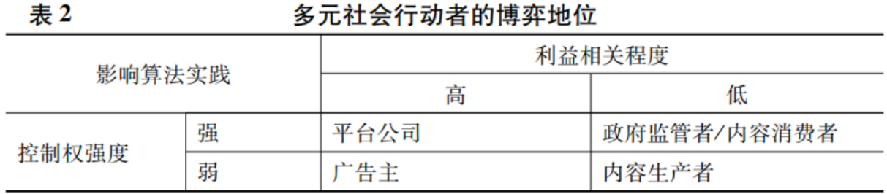

**2. Participation in the construction process: algorithm cognition and action strategies**

The status difference in the game between social actors is the basic premise for the results of participating in algorithmic practice, but it is also necessary to place it in specific practice contexts inside and outside the organization, compare in detail the process of participating in the construction of algorithmic practice, and analyze the basic cognitive differences and action strategies of multiple subjects towards the algorithm.

**1. Differences in algorithm cognition**

In the case of K platform, there are significant differences in the core social actors’ cognition and focus on algorithms. Within the platform company, the management focuses on economic and social benefits, pays attention to the balance between the instrumental rationality (efficiency) and value rationality (product values) of algorithm practice, and tends to regard algorithm practice as a mechanism to coordinate the balance of interests of platform participants. Algorithm engineers believe that algorithms are technical engines and pay more attention to the improvement of technical indicators. Content operators regard algorithms as tools to improve the efficiency of information distribution and pay more attention to whether the business indicators of their respective departments are achieved. Advertisers understand algorithm practice as equivalent to the operation of technical systems and pay more attention to how to improve advertising visibility. Government regulatory agencies understand algorithms more as a technical means, pay attention to the value rationality of technology, and algorithm practice must comply with "value correctness", improve content political security and safeguard public interests. For content producers, there are differences in knowledge accumulation in algorithm cognition, but as users of technology, they regard algorithms as factors affecting traffic monetization and pay attention to the visibility of themselves and their content. Finally, for content consumers, algorithm cognition is not important. Algorithms are basically regarded as a way of content distribution. What they focus on is whether algorithm practice can bring them a better consumer experience.

What is an algorithm? If you ask the management, it is a mechanism to balance the interests of different users in the community. For us, it is a technical engine. For content operations in various departments (commercialization/audit/government public relations/personalized recommendations, etc.), it is a means of improving content distribution efficiency. Improved indicators lead to performance. For external users, it is a tool for technical systems and applications. (Interview record of recommendation algorithm engineer C4 on November 9, 2020)

In general, algorithmic practices are opportunities for platform companies, both opportunities and constraints for advertisers, content producers, and content consumers, and constraints for government regulators (their actual frequency of interaction with technological systems is lower than that of other social actors, and they are outside the platform companies, making it difficult to regulate algorithmic practices).

**2. Action Strategy**

Through the investigation, we can find that the game status of the core actors and the basic differences in their understanding of algorithms affect their own action logic and strategies. Platform companies always play a leading role in the process of algorithm practice, directly balancing the interests of the platform and related stakeholders, and carrying out algorithm design and rule making. In the process of algorithm practice, advertisers constantly adjust their action strategies to adapt to the logic of algorithm distribution advertising, try to negotiate and bargain with platform companies to reach "interest collusion", and strive for the initiative of their own visibility game. The action logic of government regulators is discipline and guidance. Under the logic of micro-political governance, they guide and correct the rules of algorithm practice to achieve the implicit transmission of ideology and the discourse admonition and policy supervision of coercive force. Although from the overall point of view, content producers continue to adapt to the logic of algorithm practice, content producers with high interest relevance will definitely adopt game and confrontation strategies to strive for the visibility of themselves and their content. Finally, content consumers also continue to domesticate the logic of algorithm practice in the process of adapting to it, and have strategies and tactics to maintain their (in)visibility, as shown in Table 3.

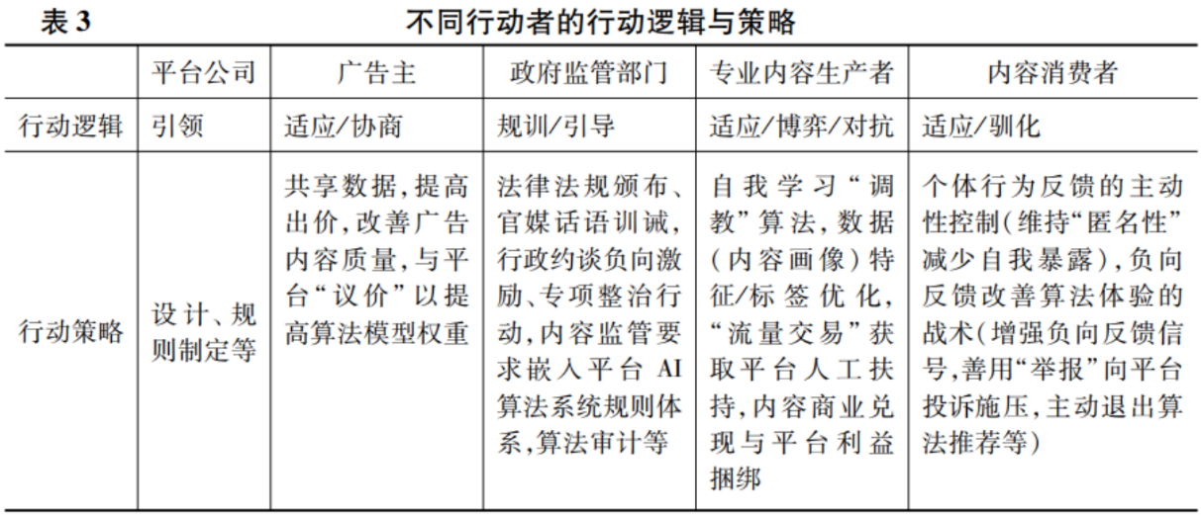

**3. The outcome of the visibility game: tension and balance under the power-interest relationship**

As mentioned above, the process of algorithmic practice is intertwined with the status differences of different social actors, differences in algorithmic cognition, and action strategies. So, what is the result of the content visibility game?

From the case of K platform, we can find that although the platform company has the highest bargaining position in the algorithm practice process, the social and cultural structure role of the platform company restricts its role as a market subject (the company's revenue and control rights come from the balance of the platform content ecology), and the power-interest relationship between it and other social actors is "interdependent" (there is no direct game conflict), so as a platform organization role, the game results of different content visibility show a dynamic balance as a whole (as mentioned above). When other social actors compete with each other, the rights and demands for content visibility conflict, the results of algorithm practice will show a certain tension at different stages (locally), and the content visibility will also show high and low differences.

For example, when algorithmic practices balance the conflict of rights between government regulators and content producers, due to the high control intensity of government regulators and strong censorship restrictions on the visibility of platform content, the visibility of political security content is relatively high. If content producers produce content that "skirts the edge of political risk", it will definitely be reviewed and blocked by the content security system. Moreover, in the presentation of information flow, content that serves political propaganda and public opinion guidance will also be given priority recommendation. "The content review system can basically cover up content that violates national laws and regulations. The platform also has an algorithm strategy that gives priority to positive energy content. It also supports traffic for content released by government agencies (within the GR system), and promotes it through high-quality resource positions on the platform (ranking positions 1 and 2 in the information flow)" (Interview record of interviewee G1 from the government relations department on 20201017).

The results of the advertising visibility game are relatively balanced. When the interests of advertisers conflict with those of content consumers, the platform algorithm practice will definitely balance the interests of both parties and its own needs. "The ads in the user's information flow will not disappear, and there will always be a slot for the ads (the 3rd and 4th positions in the information flow ranking). If the user gives poor feedback (on this ad), they will switch to other ads next time they swipe." (20200123 Commercialization Department O3 Interview Record)

Similarly, if users in the role of content producers and users in the role of consumers compete with each other, the content visibility of content consumers is relatively high, because algorithm practices (especially the recommendation system itself at the information distribution terminal) generally cater to the personalized preferences of consumers. Although the K platform is relatively more focused on the interests of content producers due to the influence of product values, whether the content of content producers can obtain greater traffic (exposure) requires the premise of constantly locking in consumer attention. The content click-through rate and retention time of consumer users are still the main measurement indicators for platform companies to measure the launch/revenue of algorithm models. Therefore, consumers have stronger bargaining power in content visibility.

The recommendation system as a whole will index, recall, and sort content based on the user's personal portrait and behavioral preferences. For example, if the algorithm pushes 10 videos at a time, it will replace some of them (to meet the needs of other business departments), such as replacing them with advertisements, e-commerce live broadcasts, content that needs to be focused on at a certain stage of the platform, or content that needs to be promoted during major national festivals. Finally, the system will weigh the rights of all parties and decide what users should watch (10 videos). However, the information flow of different users is personalized. The 10 videos you see are different from the 10 videos I see. (Interview record of C5, recommendation algorithm engineer, 20210109)

Through the above analysis, we can find that the algorithmic practice carried out by platform organizations is a complex interactive process with strong social context and highlighting the subjective initiative of social subjects. The social construction process of algorithmic practice is shown in Figure 2.

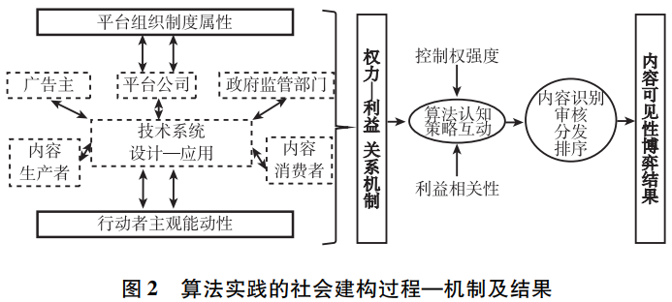

When we understand algorithms and the results of algorithmic practice, we cannot treat them as “black boxes” and simply criticize the good or bad of algorithmic practice; nor can we limit ourselves to blurring algorithmic practice into a technical system and presuppose that it is only a management and control means for organizations and manipulators. We acknowledge the practical authority and ability of platform companies as organizers, but we must also make it clear that their power and interest acquisition will be affected by the interests and bargaining power of other social entities. At the same time, the inherent attributes of artificial intelligence technology require algorithm design and manual specification of algorithmic rules (such as supervised learning data labeling manual rules, human strategy intervention, etc.), and more importantly, continuous and active data loop feedback from users. This means that the process of algorithmic practice depends on the motivation, algorithmic cognition and power-interest relationship mechanism of core social actors under a specific institutional environment and organizational structure.

In summary, influenced by the organizational institutional attributes and individual initiative, core social actors jointly participated in the construction process of algorithmic practice, and algorithmic practice became the field of content visibility game. Under the influence of the power-interest relationship mechanism, different social actors are in different game positions, and also form differentiated algorithmic cognition and complex strategic interactions, which ultimately shape the results of algorithmic practice, that is, the dynamic balance and tension of visibility game.

**V. Conclusion and Discussion**

The above series of algorithmic practices help us rethink "algorithms". We can understand algorithms as a "technical imagination" that exerts subjective initiative, an emotional cognition, or the accumulation of people's "knowledge base at hand". Algorithms are "ubiquitous" and have become a productive concept in the social and cultural field. They are debated by the public and are constantly deconstructed and reconstructed by popular discourse, news reports, and academic papers. The powerful force of public discourse on algorithms reminds us that ordinary people also have the ability to understand the meaning of algorithms - algorithmic practices can be the product of algorithm engineers and computational scientists at the technical level, and are also the result of ordinary people's active participation in the construction of perceptions, emotional experiences, and action strategies through interface interactions.

Algorithmic practice is facing us, and we are increasingly influenced by the logic of "computation". This influence is not to reveal how algorithms control people's cognition and behavior. On the contrary, algorithms shape people's behavior and the context of how to take action. Algorithmic practice presents the rules of the combination of people and code, constantly reminding us that we are in a state of mutual construction between society and technology. And to fully understand the algorithm, we also need to enter a specific social and historical context to pay attention to the specific practical process in which the algorithm is mobilized. Algorithmic practice is not humans directing machines to execute instructions and steps, but a social experimental process. Algorithmic practice cannot be regarded as a pure technical object or a pure social rule. This position helps us understand that when there is a technical deviation in algorithmic practice, we cannot simply pursue "is it the machine's fault" or "is it the human's fault", or ask "who should be responsible for the result"? Biased algorithmic cognition will definitely not get an ideal answer.

How should humans deal with the "algorithmic world"? First of all, algorithms are not a scourge, and humans need to recognize the incompleteness of the "algorithmic world". The logic of algorithms may give people an illusion: it reflects our habits and ways of existence in an unknown way. Algorithms are easily "demonized" as independent actors with autonomy, exerting "control" power over human society. This cognition is because algorithms have their own technical logic, and their autonomy comes from the fact that their computing power is faster than that of humans (Smith, 2018). They can also adapt themselves and generate norms and rules by applying human norms and rules (such as unsupervised learning/deep learning/reinforcement learning). But on the other hand, algorithms do not think and act consciously. They learn through "observation", and their reasoning logic cannot be compared with the cognitive patterns formed by human senses. They have limitations in summarizing human logic based on probability and similarity, and they tend to ignore many other aspects of human life. Secondly, algorithms are parasitic on human intelligence. When people use various applications (search engines or social media), or interact socially with robots, or drive self-driving cars, we must not forget that humans are accomplices. We don't always realize that it is humans themselves who teach algorithms and provide them with enough data to learn, at least in the beginning. Therefore, we must recognize the limitations of algorithms, apply them rationally, and be aware of the space left for human actions, reactions, interpretations, and decisions. Understanding and rationally applying algorithms means always paying attention to the practical process of the interaction between technical systems and social systems. After all, the relationship between technology and society is always an interesting and meaningful topic, and this article is also a preliminary exploration of empirical research that follows the footsteps of predecessors and the pace of the times.

In summary, the theoretical contributions of this paper are as follows: First, based on a systematic review of the literature on algorithm research in natural sciences and social sciences, this paper attempts to conduct research from a sociological perspective, turning the static inference of "technical determinism" of "algorithmic control" into a process-mechanism analysis of "social construction". Second, this paper notes the spatiotemporal continuity of AI technology design and application, and attempts to develop algorithm research based on practical logic, incorporating it into the organization-technology-individual analysis framework, and making a relatively complete observation and grasp of how different subjects are affected by organizational institutional attributes, their own algorithm cognition and action strategies, and the cyclical interactive process that affects the results of algorithm practice. Third, based on case analysis, this paper extracts two core factors that affect the social construction process of algorithm practice - the intensity of power control and the degree of interest relevance, and better clarifies the reasons and conditions for actors to participate in the construction of algorithm practice, so as to grasp the motivation and logic behind the power-interest game field.

Of course, this article's analysis of the structural factors that support this interactive process is somewhat inadequate. Under what external structural conditions should this multi-subject social construction process around algorithmic practice be understood? What is the Chinese context that shapes the social construction of algorithmic practice? What are the differences in algorithmic practices among different platform companies at home and abroad? What market competitive advantages do they have? What kind of differentiated interactions do they have with social actors? Future research should pay more attention to the constraints or promotions brought about by structural forces as external conditions in a specific time and space, and conduct additional discussions and comparative analyses of the algorithmic practice characteristics of different platform companies at home and abroad.

(Notes and references are omitted. For the full text, please see Sociological Research, Issue 4, 2022)